Hi Everyone!

I am sharing my initial work here with the Fast AI community. I want to say thanks to Jeremy Howard, Rachel Thomas and the community for this great course plus all the material / advice in the different forums and links.

**A bit about me for context:** I am a former coder / developer who now oversees the go-to-market for a healthcare application at a large consulting company. My major focus is on designing, developing, and delivering cancer screening solutions for large government organizations. If you want to see a demo of the solution you can at shorturl.at/egqtz and a great customer success video at shorturl.at/DEJTX. We have started using AI for some use cases, and I have been amazed at the results, so I have dedicated myself to learning everything possible over the last 18 months or so about AI. I would not say that I have a deep math background or (recent) depth in coding, but I have tried to keep learning over the years to stay current with the market.

**My progress so far:** I have learned a lot about how to practically work with AI, and the details of underlying concepts. This has led me to become much more involved in AI discussions at work with our clients and internally for our own operations improvements. I know how to think about the models and the options available: How we could take AI and infuse into different processes, using the volumes of data we have and generate, to create new predictions.

**My approach to learning so far has been**:

* Take the online course and read the book at the same time: I find the material complex sometimes, so consuming the course in different ways helps me to understand.
* Watch a lesson video end-to-end first to get context: It is great to get a high-level understanding of the concepts without trying to understand everything. To me it was like seeing a high-level map of where I wanted to go and how.
* Then take detailed notes: Then I watched the same lesson video a second and third time making notes on particular topics, techniques and code. This helped me to understand the strategy and syntax.
* Review tutorials: When I did not understand a topic or needed a refresher, I paused and went to different online tutorials. Example: shorturl.at/bc124 for the “Main Ideas of Least Squares and Linear Regression”.
* Run the example workbooks: I tried to run the example code block by block. Sometimes I changed or updated lines to experiment. I did not always understand the syntax, but my understanding of the options available always progressed.
* Finally, I spread out the learning and took breaks: I have read that your brain needs time to think through key concepts / ideas. There was even a suggestion to think about new concepts / problems before going to bed at night, so that your brain could process while you sleep. Personally, I found this tremendously helpful to understand new concepts…I would wake up the next day and have a better understanding of the material.

**My first model:** After running some of the example image classification models from the course, such as the dog versus cat and the forest versus bird classifiers, I decided I wanted to create my own classifier. I chose to create a simple model that classifies Canadian potato chips, based on 300 pictures that I took myself of 3 different leading brands. Below is a sample of the code and images, and you can see the entire notebook at <https://www.kaggle.com/code/michaelpartridge/canadian-potato-chip-classification>

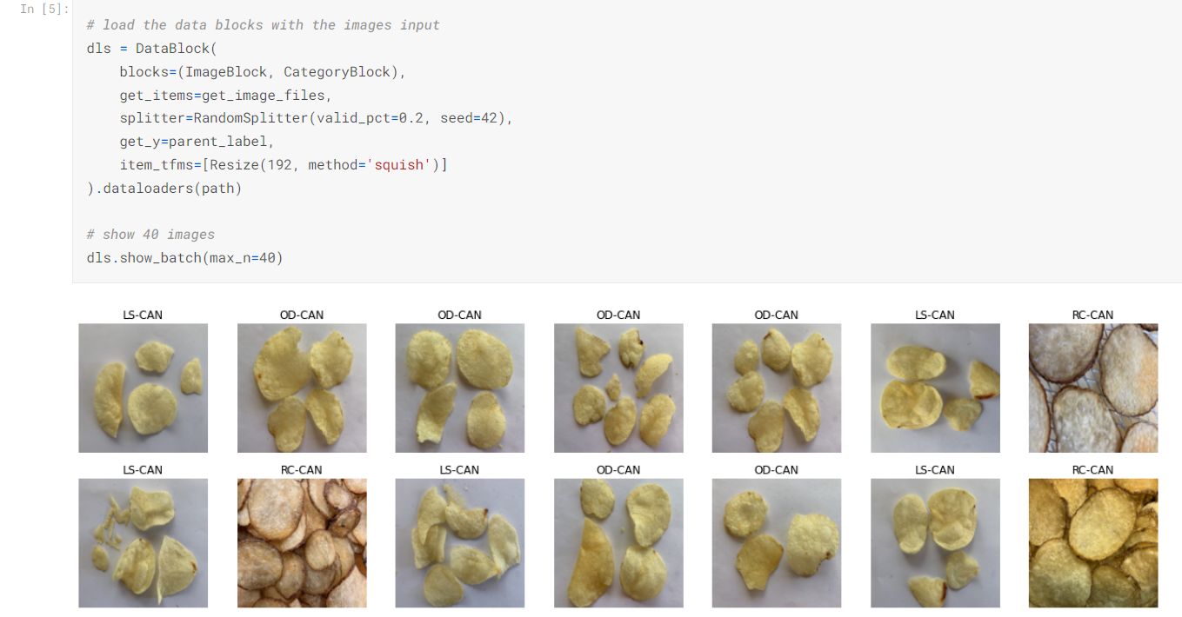

**Why this challenge?**

* It seemed a bit fun and different!
* Also a bit tricky potentially for a learner, i.e. can it really tell the difference between types of potato chips that, to a human eye, look almost identical? I thought this was a good way to see if AI really has such great potential. Said another way, yeah, I was trying my best to trick the model with similar images (sneaky I know).
* There is some societal value in this as well potentially down the line: Sadly potato chips are not very healthy for people as they contain large amounts of different toxic chemicals such as acrylamide. Acrylamide is a suspected human carcinogen that is a source of major concern not only for consumers but also for the food industry and government. There is an association between potato chip coloring and acrylamide, which forms at high frying temperatures, and varies dramatically between both potato chip producers and their individual batches of potato chips. I have been thinking about ‘what would happen if an AI app could identify not only the type of potato chip in the future, but also predict the level of acrylamide in those potato chips and therefore warn consumers not to consume if the levels are high?’ Given my professional focus on cancer screening I feel like this will be important in the future, because instead of just detecting cancer as early as possible, AI technology can be used to prevent people from consuming foods that potentially lead to cancer in the first place. Identifying the potato chip vendor and type through only an image would be the start of this AI app so this is where I choose to begin.

**The results:** The model did AMAZING well, amazing to me anyway, with a training set of only 300 images! I did not figure it would do that well! The model was able to successfully identify the individual brands and types, even from a distance! Full disclosure that I personally could not keep track of the plain potato chips associated to two different brands without the labels, but the model proved it could! Training details:

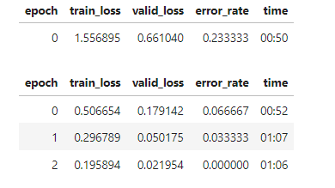

Key details of the training and validation data I created for the model:

* 300 training images in total: There 100 unique images of 3 different types of Canadian potato chips from leading vendors in the marketplace. I did not specify the actual vendor and brand names but did use codes in their place.
* 100 images were from a vendor and type that was very visually distinct, with the potato skin left on and distinct coloring (RC-CAN).
* 100 images each, 200 images in total, were uploaded for plain potato chips from 2 different vendors (LS-CAN and OD-CAN), but I on purpose selected vendors whose chips were very similar looking, almost identical to me when I looked at them. I personally doubt most people could tell the difference between these potato chips.

The tests I ran are detailed below! There were separate test images, not used in the training, again taken by me.

**Test #1:** This one was easy…so I was not surprised at this result. You can see the distinctive look of these chips.

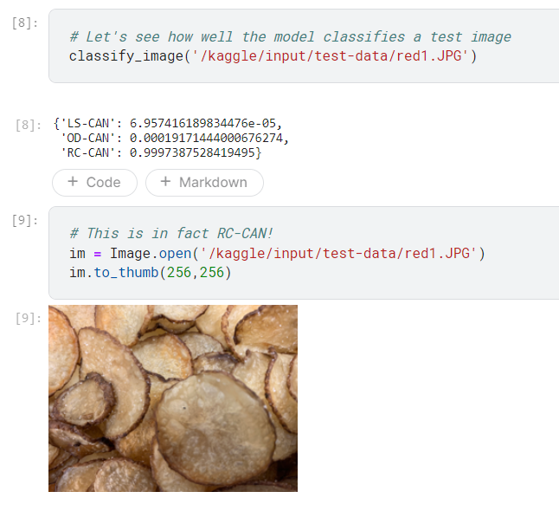

**Test #2:** The model was able to successfully identify the brand even when it was a bowl of chips sitting on a table at a slight distance (all the other training images were close ups as you can see from the other tests).

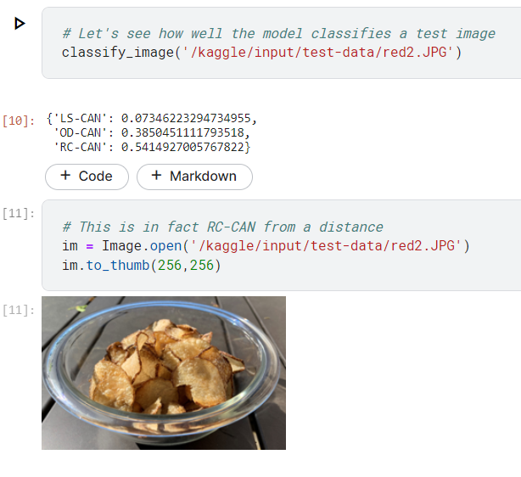

**Test #3 and Test #4:** Amazingly the model did make the right prediction for similar looking chips!

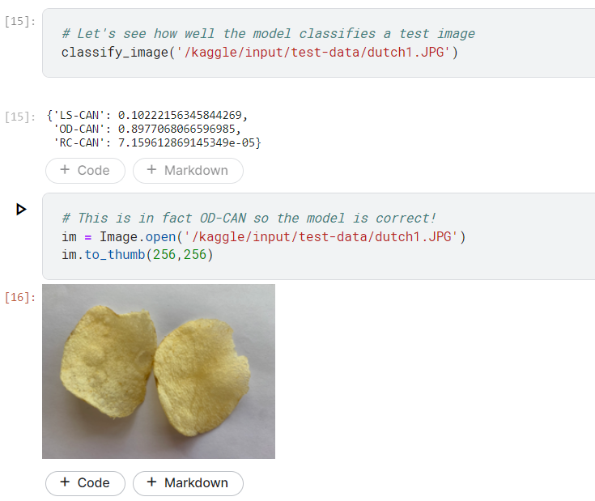

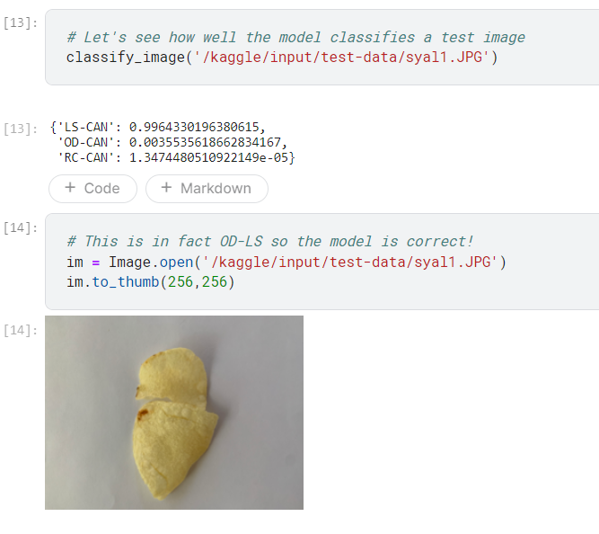

**My learnings so far:**

* Trust the learning process described in the course…run some models without understanding everything. Experiment, try things, have fun with the challenge of it!
* You don’t need millions of images or records for training. I was stunned at how few images were required. I had been working a bit with AI in my job for over a year, and I previously believed that I needed at the very least thousands or even tens of thousands of images for training until I started working through the course.
* Helpful pre-trained and pre-existing models / examples exist out there. You just have to find them and learn from them. I certainly did not create my models from scratch just using the syntax guide, but that is actually fine. I think it is a bit silly to create something from scratch if there is work you can leverage (ethically and while giving credit of course!).
* You can get results quickly! I was prepared to work on my potato chip classifier for weeks / months in my free time if that is what it took, I was so committed to learning the concepts. This now seems ridiculous as it took me only several hours over a few days to create this simple model.
* If this was a real app, there would have to be ways to get in touch to correct or update the results if they were wrong. Although perhaps trivial in this example, I think it is important to consider the ethics and implications of AI right from the beginning.

**Next steps for me:** I don’t consider this my capstone project, but I am still so excited with the results so far! I am going to continue to improve upon this work and develop a more advanced model to build my skills.

My capstone project, and my job, both relate to cancer prevention. I believe, and frankly I believe so strongly that I would say I know, that soon foods, especially potato chips, with high levels of acrylamide will be banned or come with a warning label about the potential to cause cancer. There are already warning labels on potato chips already in California! See below:

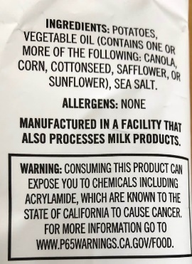

These labels and today’s detection methods are too simplistic, however. Testing by government agencies and health advocacy groups has shown that the acrylamide levels in potato chips can vary dramatically even for a specific vendors brand: from minimal levels to levels many multiples above today’s regulated maximums. In the future AI apps will be used by both consumers and manufacturers to identify particularly problematic potato chips with high acrylamide levels. Interestingly I think these AI models will leverage similar techniques that are used for finding tumors and skin abnormalities as part of cancer diagnosis. So, I am going to build a model that will predict both the potato chip type and, for a chosen vendor and type of potato chip, the level of acrylamide in parts per billion, along with some easy-to-understand interpretation of the results. I will create this data from scratch so it may take a while to complete.

In the meantime, I was also thinking of posting a larger library of potato chip images in a competition to give back to the community, so others could have something fun to try out as well. If you think that is a good idea let me know (or let me know if you think that is a dumb idea that I should not do!).

Feel free to reach out!